12.03
Fixed Assets & Depreciation
Process Design & AMOS Configuration Document
Purpose
This Process Design document is provided to Key-Users to record their key decisions regarding the AMOS Process design and the required AMOS configuration.
It is updated throughout the Project Definition Phase and used as the baseline for the Final Acceptance prior to Go-Live
Revision
Author, Name | Date | Notes
Doncho Ivanov | 01.06.2024 | First Version

Table of Contents
1. Process Overview & Objectives 3
2. Regulatory References 3
3. Definitions & Glossary 3
4. Process Tasks 4
5. Process Dependencies 4
6. Process Flow 7
7. Process Design Questions 8
8. Data Source Mapping 10
9. Other Software Used 10
10. AMOS Configuration 11
a. Process specific configuration programmes 11
b. Basic Data 11
c. Parameters 12
d. Workflows 12
e. Scheduled Tasks 14
f. API’s & Interfaces 14
11. UAT Guidance 14
12. Annex – Additional Info 15

Process Overview & Objectives
Process General Description:
This process describes a flow of tasks to enable for recording, tracking, controlling and accounting for fixed assets. It also includes the tasks needed for logging the financial impact of capital improvements or other events that increase an asset value. The required tasks to account for embedded maintenance fixed asset components is also covered by this process. The process is usually executed by the Accounting department of the organisation, who, in accordance with the accounting policy of the organisation, define relevant asset categories and applicable depreciation models and terms per category. In addition, the Accounting department is responsible to monitor and control the fixed assets and their movements in the Fixed asset register. This process is continuously performed as it is an integral part of producing accurate records to ensure compliance with accounting standards and reporting requirements.
Main Process Objective (Outputs & Outcomes):
The main objective of this business process is to manage and control fixed assets throughout their lifecycle - from acquisition to disposal, incl. depreciation – in a Fixed asset register, incl. the generation of fixed asset accounting entries in the AMOS General Ledger, which are to be exported by means of automated interface to the Finance ERP system for the purpose of bookkeeping.
In addition, the definition of depreciation models and terms, incl. setting of assets’ useful life and capitalization limit, as well as estimating the costs of embedded maintenance fixed asset components and capitalizing the costs of major capital improvements, are also covered by this business process.
The execution of this business process also provides immediate view over the state of the fixed assets, incl. their physical- and financial movements, further ensuring complete visibility, traceability and control.

Regulatory References
- Basic accounting principles
- IAS
- IFRS
- GAAP

Definitions & Glossary
Key-Words | Explanation
Spares & Equipment Fixed asset (SE) | Rotable part 1) owed by the entity, 2) whose acquisition costs can be measured reliably and 3) with useful life greater than one reporting period, during which 4) it is expected that it brings economic benefits to the entity.
Capital improvement Fixed asset (CI) | The capitalized costs incurred for regular major inspections, such as the costs of overhauls, the costs of modifications, the costs of heavy maintenance etc.
Embedded maintenance Fixed asset | The capitalized estimated carrying amount of a fixed asset component, representing the costs of major inspection or overhaul, embedded in the initial acquisition cost of an asset.
Depreciation model | Represents the pattern in which the asset's economic benefits are consumed by the entity, reflected in monthly depreciation charges.

Process Tasks
Business Process Task / Actions / Activities:
- Define asset categories: It is required for the purpose of accounting and allocation of appropriate depreciation models and terms. Example of asset categories of physical assets (SE – Spares & Equipment) are such as Tools, GSE Equipment, Engines, APUs, LGs, W&Bs, Propellers, Components etc. In addition, there is a need of also categorizing the capital improvement fixed assets, such as Component overhauls, Component modifications, AC heavy maintenance, AC modifications etc. For the purpose of categorization, it is advised to use the available part attributes in APN: 59 Part Administration, as well as to define appropriate fixed asset types in the dedicated table of APN: 18 Basic-Data Administration. All defined asset categories must be associated with corresponding accounts from APN: 1664 Chart of Accounts by means of appropriate account conditions.
- Define depreciation terms and CAPEX limits per asset category: Includes the definition of appropriate depreciation models in APN: 1565, incl. useful life, residual value CAPEX limit etc, and their association to identified asset categories in APN: 1564.
- Manage assets in fixed assets register: Fixed assets of type capital improvement (related to CAPEX projects), incl. embedded maintenance fixed asset components, as well as all assets of type different from SE, e.g. software, aircraft etc., shall be recorded in the fixed asset register; their acquisition costs shall be set, too. All assets, regardless of their type, are visible in the fixed asset register with their status and up-to-date cost information, available for monitoring and control by the Accounting department.
- Manage CAPEX projects & embedded maintenance: Includes identification and recording of costs relevant to capital improvement projects, such as major inspection, and their subsequent capitalisation, as well as the accounting estimation of such cost of major inspection or overhaul, that is already embedded in the initial acquisition cost of an asset, required to recognise them in the carrying amount of a fixed asset component, known as embedded maintenance.
- Approve fixed asset's disposal: Disposal of fixed assets (e.g. scrap) may require official authorisation from Accounting department in compliance with the accounting policy of the organisation.
- Perform month-end reconciliation, validation and closing: Includes standard month-end practices and procedures such as asset capitalisation, depreciation verification, GL accounts reconciliation with fixed asset register etc.

Process Dependencies
INPUT | CONCURRENT | OUTPUT
- 02.01 – Aircraft Phase-in: Relevant in case it is required to split AC in its major components for the purpose of running individual depreciations.  - 02.02 – Aircraft Phase-out: Required to manage with the assets installed on the AC to-be-phased-out.  - 03.04 – Modification Campaigns: Decide on capitalisation of costs of MODs.  - 08.02 – Performing Maintenance: Decide on capitalisation of cost of (major) maintenance events, e.g. Heavy check.  - 09.03 – Ordering: Decide on capitalisation of cost of (major) services, procured externally such as maintenance. Additionally, material sale, covered by this process, triggers asset disposal.  - 09.04 – Repair & Exchanges: Decide on capitalisation of cost of (major) shop visits.  - 10.02 – Goods Receiving & Inspection: Required for capitalisation, e.g. of SE assets.  - 10.03 – Major Assemblies: Relevant in case it is required to split major assembly in its components for the purpose of running individual depreciations.  - 10.06 – Inventory & Shelf-Life Control: Loss in inventory triggers asset disposal.  - 11.04 – Component Maintenance: Decide on capitalisation of cost of (major) maintenance events, e.g. Overhaul.  - 12.02 – Invoice Checking: Fixed asset acquisition cost adjustment (as required).  - 12.07 – Financial Multi-Entity: Relevant to asset acquisitions and disposals (sale) in the context of intercompany transactions. Also, decide on capitalisation of cost of (major) shop visits to intercompany shops. | - 12.01 – Financial Accounting: Generated accounting postings, required for subsequent asset capitalisation.  - 12.06 – Budgeting & Cost Controlling: Define project numbers as capital improvement projects. | - 12.01 – Financial Accounting: Generated accounting postings.  - 12.04 – Commercial Pricing & Billing: Sold assets available to bill to customers.  - 12.06 – Budgeting & Cost Controlling: Generated relevant cost bookings.

Process Flow
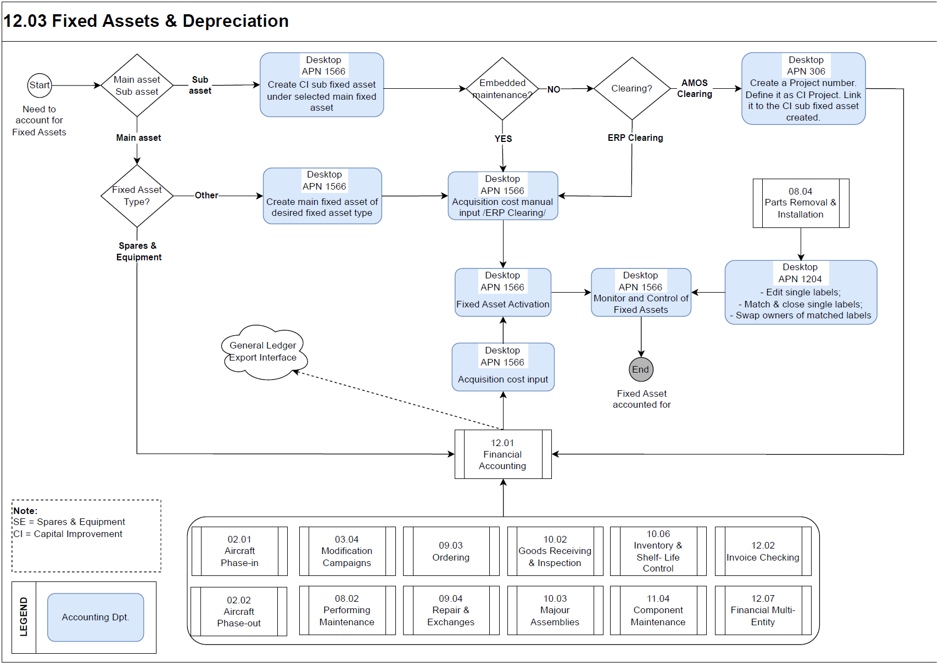

Process Design Questions
# | Question | Answer
1 | What is the definition of a fixed asset in your organisation?
2 | Are fixed assets classified in asset types/categories? - e.g. FA Engine vs FA APU vs FA components vs FA tools etc.
3 | What is the depreciation method used in your Entity? - Straight-line vs Units-of-Production vs Hours-of-Service vs Others
4 | Is there minimum capitalization threshold/limit set in your Entity?
5 | How is the fixed asset's useful life measured? Does it depend on the phase-out date of the last AC from the fleet?
6 | Do asset types/categories follow fleet-specific depreciation model? - e.g. Boeing fixed assets have different depreciation terms compared to Airbus fixed assets; fixed asset components have different depreciation terms compared to fixed asset tools and equipment etc.
7 | How is the fixed asset initially recognized? What is included in fixed asset's acquisition cost?
8 | How is the fixed asset measured after the initial recognition? - Cost model vs Revaluation model
9 | If the cost model is used:  Do you depreciate separately each part of the fixed asset item with a cost that is significant in relation to the total cost of the item? Or is the fixed asset depreciated as a whole?  Consider the example of AC and its individual parts or Assembly, e.g. Engine and its individual sub-components.
10 | Are fixed assets impaired in your Entity?
11 | How do you treat embedded maintenance?
12 | Are there any Capital Projects in your Entity? Are capital expenditure recognized as fixed assets and depreciated over time? - e.g. the cost of Engine overhaul, the cost of C-check, the cost of Modifications etc.
13 | Are there assets held for sale (exclusively) in your entity?

Data Source Mapping
Data Sources | Description | Volume / Manual / Automatic / Static / Dynamic
-/- | -/- | -/-

Other Software Used
Other Software | Used by: | Description
-/- | -/- | -/-

AMOS Configuration

Process specific configuration programmes
AMOS APN | Notes
APN: 59 Part Administration | Define which rotable part numbers are to be accounted for as fixed assets (fixed asset type SE).
APN: 1664 Chart of Accounts | Define the necessary account numbers, used in the fixed assets management & depreciation process.
APN: 1658 Financial Transaction Definition | Define the necessary financial transactions, used in the fixed assets management & depreciation process.
APN: 1565 Depreciation Model Definition | Define depreciation models with applicable useful life, residual value capitalization limit etc.
APN: 1564 Depreciation Model Scheme | Associate defined depreciation models to each asset category.
APN: 306 Project Administration | Define project numbers as capital improvement projects. Costs of major inspections shall be identified and recorded within a project for the purpose of subsequent capitalization.
APN: 1204 Bookings Analyser (Financial) | Match component installations and removals, and/or swap owners between components to maintain up-to-date fixed asset register with a physical component actually under depreciation.
APN: 14 Admin Logins | Define the user logins and assign them to user roles.
APN: 15 Admin Roles | Define user roles and assign access rights (licenses) to each of them.
APN: 146 Staff Management | Define employee data. Link each employee to Financial entity.
APN: 1404 AIM Configuration | Configure required export interfaces. Scheduler task required to trigger the actual interface.
APN: 1470 AIM Webservice Configuration | Configure required export interfaces. No scheduler task required.

Basic Data
Basic Data Table | Notes
Specials Contract | It may be used in order to differentiate between fixed asset categories, e.g. Engine, Landing Gear, APU, Propeller, Wheels & Brakes
Fixed Asset Type | Contains the Fixed Asset Types used to differentiate the physical Spares and Equipment (SE) fixed assets and the Capital Improvement (CI) fixed assets (e.g. Overhaul or Modification, occurring during the SE fixed asset life cycle). The main asset types, different from SE, such as Aircraft, Software etc., recorded and capitalized in the fixed asset register, and depreciated individually, must be defined here, as well.

Parameters
Parameter Code | Parameter Name | Notes
1501 | Activate Fixed Asset Accounting | Activate fixed asset modules and depreciation functionalities.

Workflows
Workflow Number | Workflow Name | Workflow Setup Notes
303 | Matching Of Single Bookings | AMOSdesktop only: This Workflow will be triggered by Rotables Label Booking, Component Booking, Component Tree Label Booking, Workorder, when a single label booking is performed. If the given conditions are made and single bookings exist, AMOS will automatically match them.
304 | Owners Swapping on Label Bookings | AMOSdesktop only: This Workflow will be triggered by Rotables Label Booking, Component Booking, Component Tree Label Booking, Workorder, when a single label booking is matched, or a full label is performed. The Owners Swap happens automatically when this workflow is active. This will update automatically the fixed asset register with the new serial number under active depreciation within the existing fixed asset object ID.
404 | Depreciation Swap on Label Bookings | AMOSdesktop only: This Workflow will be triggered when two single label bookings are matched, or a full label booking is performed. The Depreciation Swap can happen only when the following criteria are fulfilled:  -Both involved Rotables are Fixed Assets;  -Both involved Rotables belongs to the same Financial Entity;  Once the criteria are fulfilled, the fixed asset register will be updated, where the Fixed Asset IDs assigned to the concerned Rotables will be swapped as well as their existing Book Value.  To abort Depreciation Swap you must set the conditions that lead to a Condition Abort Action.  Note: If an Owners Swap is executed, the existing Depreciation(s) will be automatically swapped.
431 | AMOSmobile Matching Of Single Bookings | This Workflow will be triggered by Book Component Change when a single label booking is performed. If the given conditions are made and single bookings exist, AMOS will automatically match them.
432 | AMOSmobile Owners Swapping on Label Bookings | This Workflow will be triggered by Book Component Change, when a single label booking is matched, or a full label is performed. The Owners Swap happens automatically when this workflow is active. This will automatically update the fixed asset register with the new serial number under active depreciation within the existing fixed asset object ID.
434 | AMOSmobile Depreciation Swap on Label Bookings | This Workflow will be triggered when two single label bookings are matched, or a full label booking is performed. The Depreciation Swap can happen only when the following criteria are fulfilled:  -Both involved Rotables are Fixed Assets;  -Both involved Rotables belongs to the same Financial Entity;  Once the criteria are fulfilled, the fixed asset register will be updated, where the Fixed Asset IDs assigned to the concerned Rotables will be swapped as well as their existing Book Value.  To abort Depreciation Swap you must set the conditions that lead to a Condition Abort Action.  Note: If an Owners Swap is executed, the existing Depreciation(s) will be automatically swapped.
332 | Part | This workflow may be used to control the user input when a new part is created. For instance, when in the organisation all Rotable parts are Fixed assets, then it must be ensured that when a new R-part is created the FA flag is set.  Use the conditions ABORTABLE = YES & ACTION = ADDED & any other relevant conditions in combination with Conditional Abort Action.
170 | Part Saving | Use this workflow to control modifications of part definition properties. For instance, when in the organisation all Rotable parts are Fixed assets then it should not be allowed to remove the FA flag for a Rotable part number.
149 | AIM Export has completed | Setup workflow to monitor the errors of the export GL interface (in case of export selector specific to fixed asset movements).
97 | AIM Logging Notification | This workflow is triggered whenever ERROR_LOG or a WARNING_LOG is written by AIM. It may be used to send an e-mail with the log message.
12 | Scheduler Task Message | Setup workflow to monitor the errors of the DepreciationGeneration scheduler task.

Scheduled Tasks
Scheduled Task Reference | Frequency | Notes
DepreciationGeneration | Last day of the month | Automatically generates depreciation charges according to applicable depreciation models and schemas.
GeneralLedgerExportTask | daily | Generates accounting entries in AMOS General Ledger.

API’s & Interfaces
Reference | Direction | Trigger | Frequency
TRANSFER GENERAL LEDGER | Export from AMOS | Generated transferable fixed asset accounting postings. | 2*day

UAT Guidance
Test case number | Test case description | Required data | Required resources
1 | Configure Depreciation model per asset type with useful life, residual value and capitalization limit. | Accounting policy | Accounting
2 | Assign Depreciation model per asset category. | Depreciation model | Accounting
3 | Activate Main SE fixed asset for depreciation. | Received fixed asset on Purchase order with receiving date in the past.  Applicable depr. model | Accounting
4 | Create CI fixed asset for SE fixed asset. | Active SE fixed asset | Accounting
5 | Open a CI project and link to CI fixed asset to collect costs to be capitalized. | CI fixed asset created | Accounting
6 | Analyse CI project costs to be capitalized. | Closed CWP with linked CI project | Accounting
7 | Capitalize the costs on the CI fixed asset. Perform ‘AMOS Clearing’. | Dr balance on Tech. Asset Clearing account | Accounting
8 | Activate CI fixed asset for depreciation. | Applicable depr. model | Accounting
9 | Dispose CI fixed asset. | Active CI fixed asset | Accounting
10 | Create Main fixed asset of type different to SE. | Fixed asset type | Accounting
11 | Capitalize the costs on the Main fixed asset. Perform ‘ERP Clearing’. | Finance ERP accounting data | Accounting
12 | Activate Main fixed asset for depreciation. | Applicable depr. model | Accounting
13 | Create CI fixed asset for the Main fixed asset. | Active Main fixed asset | Accounting
14 | Open a CI project and link to CI fixed asset to collect costs to be capitalized. | CI fixed asset created | Accounting
15 | Analyse CI project costs to be capitalized. | Booked Service order with linked CI project | Accounting
16 | Capitalize the costs on the CI fixed asset. Perform ‘AMOS Clearing’. | Dr balance on Tech. Asset Clearing account | Accounting
17 | Activate CI fixed asset for depreciation. | Applicable depr. model | Accounting
18 | Dispose Main fixed asset (together with the linked CI fixed asset). | Active Main fixed asset | Accounting
19 | Run the DepreciationGeneration task and verify the task log. | Scheduler task setup | Accounting
20 | Verify the General ledger accounting entries.  Use also APN: 1627 Consistency Analyser. | Configured Financial transactions and Chart of Accounts | Accounting

Annex – Additional Info
-/-

